DONCASTER CIVIC THEATRE

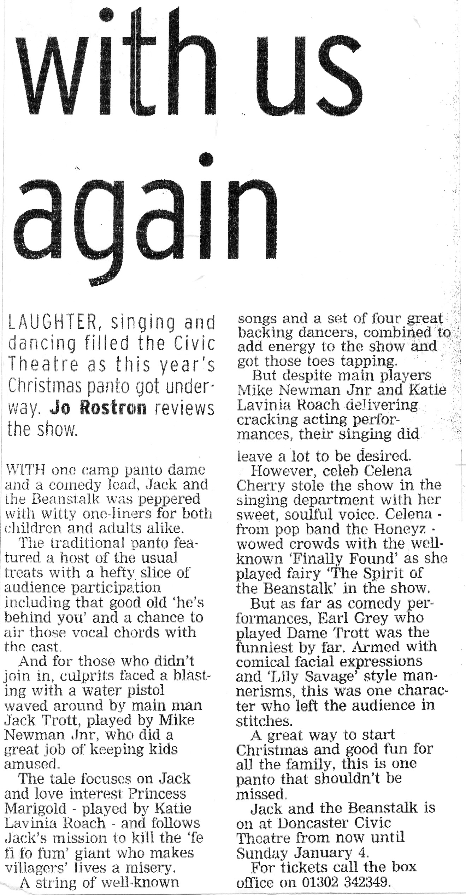
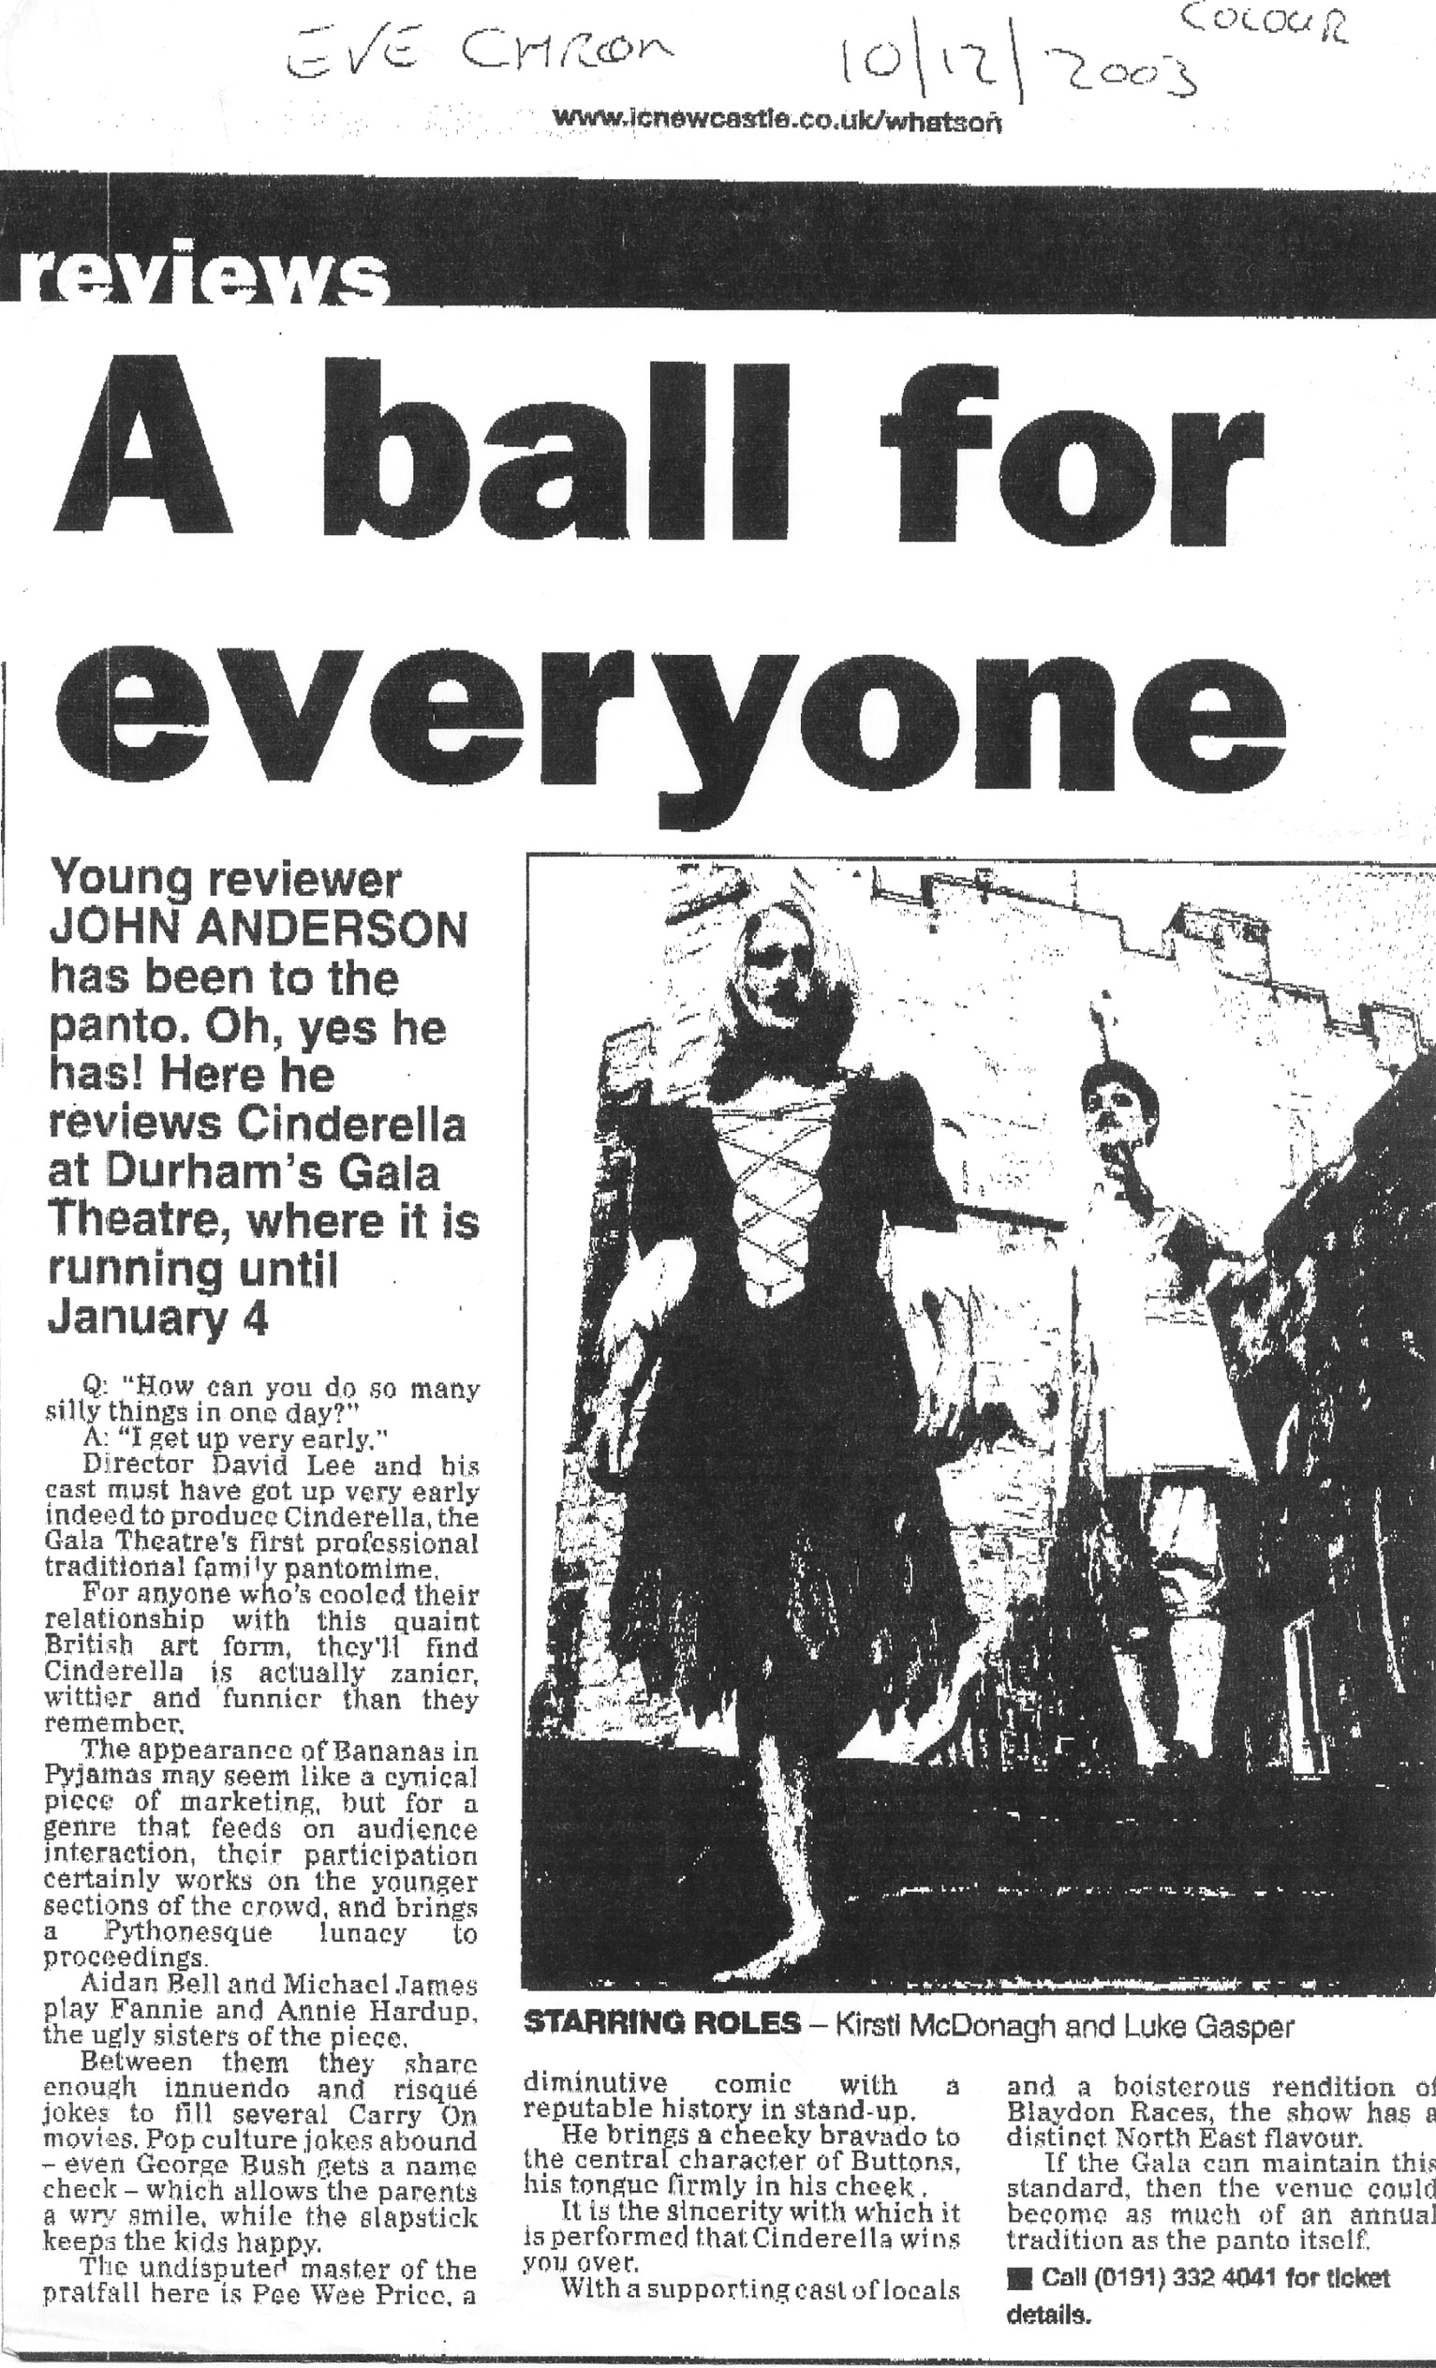

DURHAM GALA THEATRE
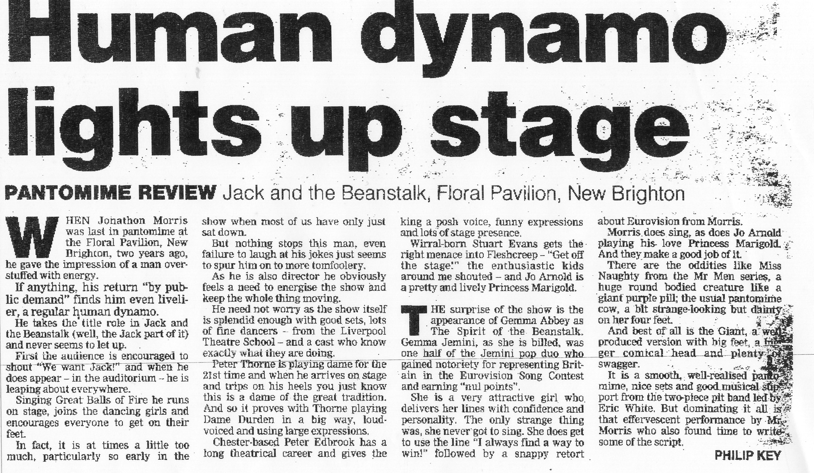

NEW BRIGHTON

FLORAL PAVILION

